 | Apartment  “Manabigaoka College Heights”  学が丘カレッジハイツ |  | Apartment  “Gakuennishi College Heights”  学園西カレッジハイツ
 | 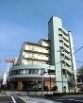 | 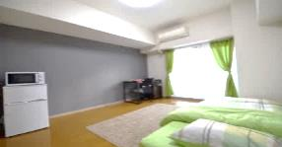 | 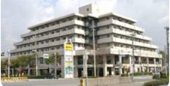 |  | 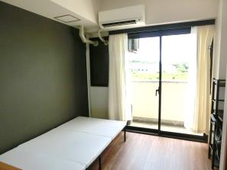
 | 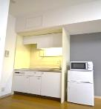 | 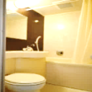 | 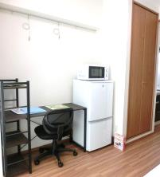 | 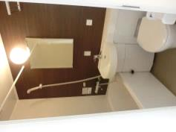 |  | 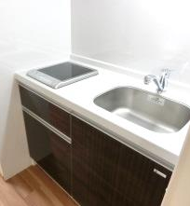
Size of a room | 25 m² |  | 18 m²
Access | - 2.2 km from KCUFS  - 6 minutes by bus from the nearest bus stop to KCUFS  - Bus Routes:  54, 50, 11,51,48, 53, 121 and 171  - 1 minute walk to the nearest bus stop  *The bus fare is 210 yen per ride. A three-month commutation ticket from the apartment’s nearest bus stop to KCUFS’s costs 23,940 yen. |  | -1.2 km from KCUFS  - Approximately 15 minute walk from KCUFS
Surroundings | - Bus stop is in front of the apartment building.  - A convenience store is in front of the apartment building.  - 600 m from the nearest super market.  - Family restaurant on the first floor of the apartment building |  | - 1.0 km from the nearest super market.  - Italian cafeteria on the first floor of the apartment building
Includes | Internet (Wired and wireless networks), Air Conditioning, Kitchenette, Bathroom, Closet, Shoe Closet, Shared Laundry (100 yen/use), Bed, Bedding, Refrigerator, Chair, Desk, Microwave oven, Curtains, Rug, Utilities(Electricity, Gas, Water)  *Apartment's furnishings are subject to change. |  | Internet (Wired and wireless networks), Air Conditioning, Kitchenette, Bathroom, Closet, Shoe Closet, Laundry, Bed, Bedding, Refrigerator, Chair, Desk, Microwave oven, Curtains, Utilities(Electricity, Water)  *Apartment's furnishings are subject to change.
Excludes | Meals  Daily necessities  Kitchenware |  | Meals  Daily necessities  Kitchenware
Initial Fee and Accommodation Fee  (Non-refundable) | Initial Fee: 25,000 yen  Accommodation Fee: 279,000 yen/Semester
Payment Deadline | - October 15, 2021 for the initial fee and the accommodation fee for the Fall Semester, 2021  - April 30, 2022 for the accommodation fee for the Spring Semester, 2022  * Students must make a one-time payment of accommodation fee for each semester after their arrival to KCUFS. Payments are made in Japanese yen in cash at KCUFS's nearest post office.
Designated Arrival Date | At 11:30 am on Monday, September 6, 2021 at KCUFS International Office
Accommodation Period | Students must vacate their apartment no later than:  - February 28 (Students who leave Japan after the fall semester ends)  - August 25 (Students who leave Japan after the spring semester ends)  * Students must vacate their apartments according to the KCUFS apartment vacating rules. The rules will be announced to the accepted students at a later date.

